**CET_4811 – Computer Controlled Systems II**

**Preliminary project proposal (Part A) for a computer controlled electro-mechanical device.**

Proposal (Part A) due date: **3rd class session**

Project Name: Automated House System

Group Members: 1. Cristhian Suriel

2. Lordain Bonaventure

____________________________________

This preliminary project idea is to be submitted by each group of **not more than three students**.

Write a one paragraph description and draw a simple sketch (block diagram), on the other side of this sheet, of your idea of a computer controlled device that you would like to build for the capstone project. The mechanical device must be a simplified model of a real world device that you can build from mechanical components obtained from LEGO, K’NEX, or VEX kits, or a disassembled toy. You can also build your device from raw materials such as wood or plastic.

**Use of a commercial kit to assemble and build the entire project is NOT allowed.**

The main requirements of the project are that the device must:

1. be controlled by a high level language (C/C++) program,
2. make use of an embedded micro-controller,
3. incorporate at-least two simple input sensors (analog and / or digital sensors)
   * Examples: switch, potentiometer, temperature sensor, light sensor (photo-resistor)
4. incorporate one advanced input sensor
   * Examples: IR receiver, IR or Ultrasonic distance sensor, Tilt/Gyro sensor
5. incorporate at-least one motor (DC, servo or stepper motor) as output actuator,
6. incorporate at-least one other output device (e.g. LEDs/LCD or Speaker)
7. connect the device to a computer network for network data transmission or control, with the help of wireless (Bluetooth, Zig-Bee, Wi-Fi) or wired (USB, Ethernet) technology.

Indicate the location of sensors and motors in the sketch.

Carefully consider the time needed to buy or obtain parts and kits and to put the device together. **The mechanical sub-system of the device must be in reasonable working order by mid semester**.

To come up with an idea, look around your house, in public places and on the road, for devices, appliances and structures that are controlled by motors.

**Block diagram of the computer-controlled device:**

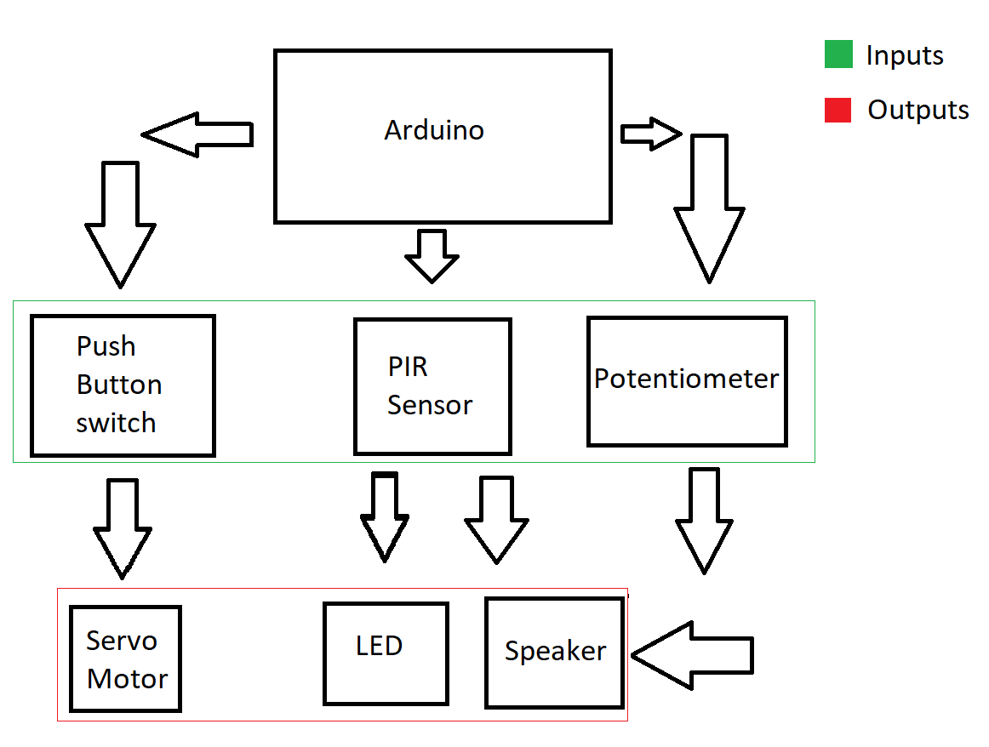

**Brief description of operation:**

We’re building a mechanism to simulate a house with automated doors, a house alarm and speakers with the purpose of communication. For this project we’ll be using a PIR sensor, LEDs, Servo motors, a potentiometer, Speakers. Push buttons, Wires, and resistors.